Software Paper
Spaghetti: Visualization of Observed Peptides in Tandem Mass Spectrometry.
Steven Lewis*¹, Terry Farrah¹, Robert L. Moritz¹, Eric W. Deutsch¹ and John Boyle¹
¹Institute for Systems Biology, Seattle, Washington, USA.

Received on XXXXX; revised on XXXXX; accepted on XXXXX

Associate Editor: XXXXXXX

abstract
Background: We present a visualization and analysis tool, called Spaghetti, for the exploration of mass spectrometry detected peptides and their structural locations. Studying patterns of peptide location across a protein can be used for many purposes: exploring PTM (post translational modification) locations with respect to putative protein active sites and protein-protein interaction sites; verifying the reliability of a protein inference by exploring peptide coverage and biases to specific regions; and studying biases in the distribution of detected peptides across protein secondary structure elements, structural domains, and protein chains. Spaghetti allows data about protein structure to be merged with data on the collection of detected peptides in tandem mass spectrometry.
Spaghetti produces two dimensional and three dimensional views of the relationship between observed peptides and protein structure including visualization of the locations of the peptides. Coverage statistics and analysis are provided. This tool has been coupled with the Peptide Atlas, a compendium of millions of peptide observations from experiments conducted in dozens of diverse laboratories, to allow the inclusion of as large a collection of data as possible..

Results: We present a program for displaying data about the relationship of fragments collected in proteomic tandem mass spec studies and structure of the protein .
Conclusion: While denaturation may destroy much structure, visualization of the structure may be a good way to consider which peptides are and are not detected in mass spec proteomic studies.

introduction
Tandem Mass spectrometry has proven to be a powerful tool for identifying and quantifying proteins . Peptide Atlas is a high quality repository of proteins and known detected peptides. An important issue in proteomics is the fact that most spectra currently detected cannot map to a specific peptide. Also a significant fraction of the amino acids in known proteins are not in any detected fragment.
The function of this work is to integrate knowledge of detected peptides with existing knowledge of the three dimensional structure of proteins to aid in understanding of the factors responsible for certain portions of the protein structure being strongly detected in tandem mass spectrometry while others are detected weakly or not at all.

SYSTEM AND methods
The code is written in Java. The code has two elements. The first generates a web page describing the peptide fragments observed from a specific protein. Starting with a UniProt id , the sequence of the protein is downloaded from the UniProt {Citation} database together with a list of any available 3D Structure. In the absence of existing 3d models, the positional features are inferred from Uniprot's sequence annotation.

Data Sources
When presented with a protein represented by a uniprot id,(ref) the program searches the web for information about the protein. The critical sites implement access to the critical information using REST interfaces.
- Sequence and Structure
The uniprot database feature annotation defining local secondary structure as well as other features (6a) . The program extracts and displays the following annotations: Helix, Sheet DiSulphide Bond and Turn. When a three dimensional model is available, the features are extracted from that model.
- Three Dimensional Structure
The relevant three dimensional models are mentioned in the ??? file from uniprot. These files may be downloaded from pdb.org (ref). Not all pbd files will provide a useful three dimensional structure. The details of this use are provided below.

IMPLEMENTATION
The program may start with a specific listing in Peptide Alas{5a}.
The tool also has a web interface which supports building a viewer of arbitrary view specifying only the UniProt id and an list of detected fragments. Protein sequence and known 3d structure are detected by querying the UniProt site and parsing sequence and features (helix, sheet, turn …) from the UniProt database. If 3d models (PDB) are available, these are downloaded. The sequence is compared with the 3d model to identify matching segments.
The display consists of two parts: three dimensional view and sequence view.

3 D view
The best 3d model (if present) assessed by matching the highest fraction of the protein’s sequence is displayed in a JMol applet viewer. A collection of scripts are generated in the page to highlight critical features of the model. The selectable views are peptide, hydrophobicity, solvent access and coverage.
Peptide view executes a script to assign colors to atoms in the detected peptide sequences. Because it is frequently the case that sequences in detected peptides overlap, that is the same amino acid will be present in several detected peptides, only the latest color will be highlighted. A selector allows the coloring to be set for a single peptide sequence.
Coverage view simply highlights the amino acids detected in any peptide. This leaves as gray any region of the protein which is never detected.
Solvent access looks at the atoms within the model. After coloring all atoms red, it shows all atoms accessible to the solvent using the Shrake-Rupley algorithm {2a} in a transparent view. The view was developed as a validation of the algorithm but also to view solvent accessible portions of the protein.
The hydrophobicity view shows the peptides colored by hydrophobicity from red, most hydrophobic to blue, most hydrophilic. In this view cysteines with disulphide bonds are shown in green.
Other controls allow the view to either show individual atoms or ribbon structure of proteins and to show or not show specific chains in the molecule.

Sequence View
Other controls allow the view to either show individual atoms Sequence view shows the protein sequence as a collection of amino acids. Above the amino acids, the detected peptides are shown as a series of colored rectangles with the colors corresponding to the coloring of any three dimensional view.
The text is additionally colored to show coverage. The background color of each amino acid highlights any detected features, helix, sheet, disulphide bonds, turn and missed cleavages.

User Access
The web site http://www.spaghetti_proteomics.org can generate a web page for any protein and set of fragments. If you fill in the UniProt id and a set of detected fragments, it will generate and show a web page showing the fragments aligned relative to the protein structure and any detected and useful 3D models. A selected set of proteins and fragments from Peptide Atlas are also available.

DISCUSSION
Spaghetti is a tool to integrate the information in Peptide Atlas on peptide detection in proteins to existing 3D structure of those proteins. In addition to providing a tool for visualization, the tool can be used to help determine why certain peptides are detected and certain region of protein molecules are found in many detected peptides and others are not.
Proteins are normally denatured prior to digestion for proteomic analysis. This denaturation raises questions as to the relevance of any prior three dimensional structure. Visualization of the relationship between known three dimensional structure and detected fragments may prove useful in seeing where denaturation may be incomplete and the dimensional structure may affect digestion and detected peptides.

AVAILABILITY
The full source code, documentation and test code is available at http://code.google.com/p/hydra-proteomics/

ACKNOWLEDGEMENTS
This project is supported by Award Number R01GM087221 from NIGMS and R01CA137442 from NCI, major research instrumentation grant 0923536 (to RM) and we also thank the Luxembourg Centre for Systems Biomedicine and the University of Luxembourg for support. The content is solely the responsibility of the authors and does not necessarily represent the official views of the NIH.

REFERENCES
(1a) – temporary ref until I figure out endnote

(1a) Baumgardner, L., A. Shanmugam, et al. (2011). "Fast Parallel Tandem Mass Spectral Library Searching Using GPU Hardware Acceleration." Journal of Proteome Research 10(6): 2882-2888.

(2a) Shrake, A., and J. A. Rupley. "Environment and Exposure to Solvent * of Protein Atoms. Lysozyme and Insulin." JMB (1973) 79:351-371

(3a) Lesser, G.J., Lee, R.H., Zehfus, M.H., and Rose, G.D., "Hydrophobic Interactions in Proteins," in Protein Engineering (Oxender, D.L. and Fox, C.F., eds.) Alan R. Liss, New York, pp. 175-179 (1987).

(4a) "Integration of Peptide Sequences Obtained by High-Throughput Mass Spectrometry with the Human Genome", Genome Biology 2004

(5a) "The PeptideAtlas Project", Nucleic Acids Research, 2006, 34, D655-D658

(6a) http://www.uniprot.org/manual/sequence_annotation

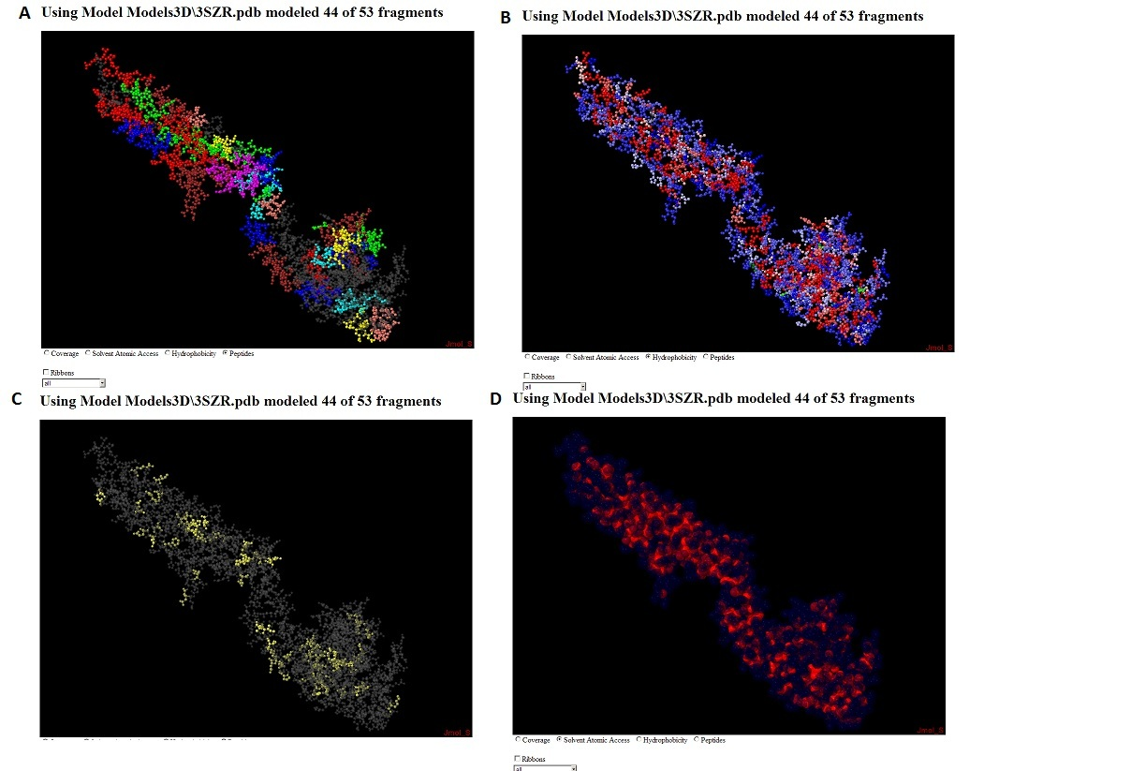

Figure 1
A) Peptide view - detected peptides are shown in the same colors as in the sequence view below. B) hydrophobicity view - peptides are shown on a scale from red to blue with red representing the most hydrophobic. C) coverage view - color shows single or multiple coverage. Grey peptides have no coverage. D) Solvent exposure view - in this view atoms exposed to solvent are shown in a transparent blue. others are in solid red.

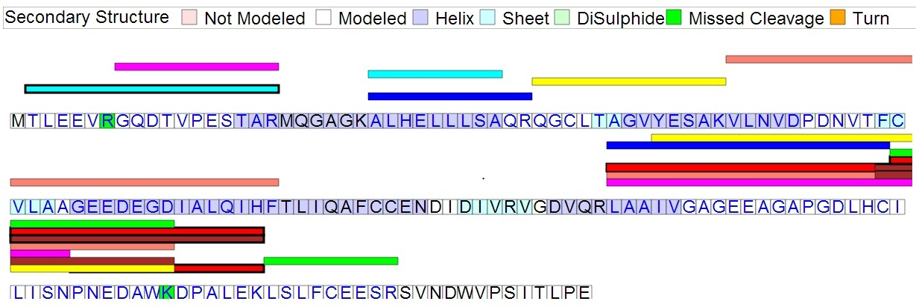

Figure 2
Sequence view – detected fragments are shown imposed on the protein sequence. Three dimensional data if inferred from annotated attributes or (if available) three dimensional modeling. Fragments containing missed cleavages are shown with heavy borders. In addition to three dimensional structure, missed cleavages are shown. Text color of the amino acids is used to highlight whether any coverage is present.

*

